# Postmen will now report suspicious incidents to the police under new scheme

* Daily mirror [19 MAY 2015](http://www.mirror.co.uk/by-date/19-05-2015) **BY** ALAN JONES

## Royal Mail said more than 130 postmen and women will take part in the Mail Watch initiative

PA

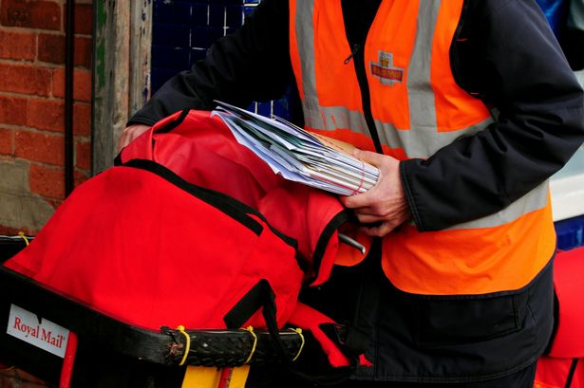

Postal workers will report low-level crime or suspicious incidents to the police under a new scheme being trialled

Postal workers will report low-level crime or suspicious incidents to the police under a new scheme being trialled.

[Royal Mail](http://www.mirror.co.uk/money/city-news/royal-mail-privatisation-postal-workers-2026809)said more than 130 postmen and women in Winchester, Hampshire, will take part in the Mail Watch initiative.

Tony Marsh, director of security at Royal Mail, said: "Royal Mail postmen and women collect and deliver mail six days a week and have almost-unrivalled knowledge of the communities they serve.

"We are proud to be formalising our working relationship with Hampshire Constabulary and Neighbourhood Watch through the launch of this important initiative, and look forward to playing our part in creating a safer community."