

The Safety & Health Expo is the largest H & S event in Europe; it combines the IOSH conference, CoreSkills+ and LiftEx, the Facilities Show, Energy & Environment Expo, Firex International, Service Management Expo and IFSEC International. There were many useful free educational programmes on with trusted content and critical advice on legislation alongside the latest products on the market and the newest innovations. There were practical demonstrations from top suppliers, all the major industry bodies including IOSH, RoSPA and the BSIF.

The first Fleet 21 speaker was ex-Royal Mail and spoke of “Driving For Better Business” (DfBB). Melvin Hodgetts used to be Safety Directors at Royal Mail Logistics and he took RM into DfBB in 2008 being the first major organisation to do so. Despite the attention given to safe driving systems by UK companies around 200 people are killed or seriously injured every week on our roads. Note that there are many more 20mph zones, are these being taken into account when planning your drivers day – it will take longer to be safe and legally. Their website is [www.drivingforbetterbusiness.com](http://www.drivingforbetterbusiness.com) .

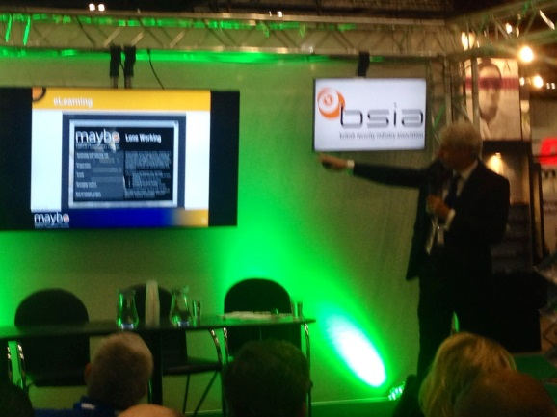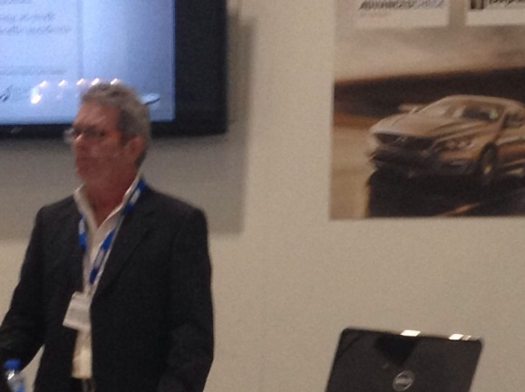

Lone Worker speaker from North Star Teesside Housing was Keith Saunders; discussed the new smartphone app called Peoplesafe – it can be just shaken to activate with two way speech and a GPS signal to locate. However I would expect this to have a lot of false alarms, that can then lead to real emergencies being ignored as there had been so many “crying wolf” previously. He was particularly enthused by the Vision Management Platform.

Whilst I was discussing general issues with someone from the health and safety executive she asked about my live issues. I mentioned concern over a current company change to documentation which said that the fire and rescue services were the first point of call outside normal working hours she wasn’t impressed and called over a senior colleague. He was less impressed and called over his boss who advised me to pursue the issue as the company, as we expected, are wrong.

I was of course careful not to mention BT but they [the HSE people] may have seen it on the front of the report [see box overleaf] I had written when complaining about the issue to CWU Head Office.

“**NOTE:** The Pole Emergency Recovery procedure is not meant to provide 24/7 cover. Outside of normal working hours we would fall back on the emergency services, if a pole emergency recovery was required”.

I have informed Head Office that the HSE have told me what to do next. Following the discussions with the inspectors – we were treated to a demonstration of a rescue; the demo was the reason for me being next to the HSE discussing general safety issues and rescue from height specifically. It wasn’t planned at all.

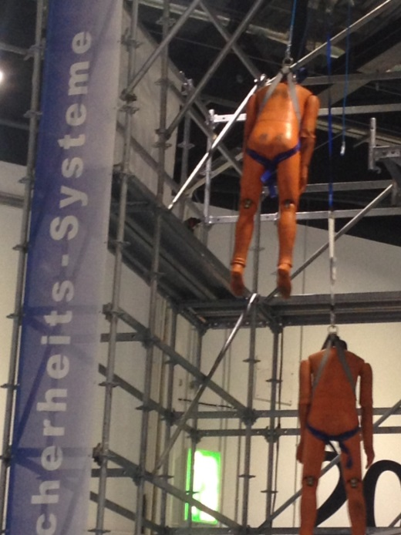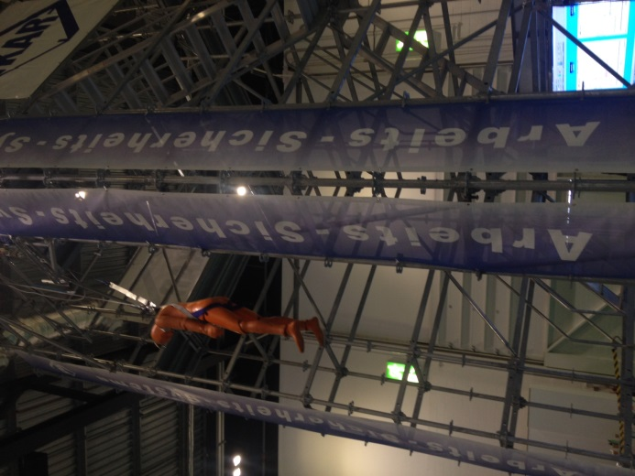

There were six theatres in the Safety and Health Expo – Occupational Hygiene, Lone Worker, SHP Legal, Driver Safety, Safety and Health Live and LiftEx innovation. These all have speakers on so you can pick and mix as required to get the most out of the time. There are also more in depth sessions but they cost £70 [they call them Master Classes on core skills] each to go to.

The Firex International was in the next hall and I was hoping to speak to someone from the Fire Brigade Union but they did not have a visible presence. I didn’t know the amount of different fire types; they include magnesium fires, sodium fires, lithium fires, potassium fires, titanium fires and zirconium fires – and that’s just for aqueous vermiculite dispersion extinguishing.

### Mike Slater, the president of the [British Occupational Hygiene Society (BOHS)](http://www.councilforworkandhealth.org.uk/bohs)said that ill health does not get the press it deserves - 3,700 workers in 2012/13 suffering from occupational cancers such as mesothelioma. The HSE estimates that 13,000 workers a year die of occupational diseases but as these diseases take a long time to be seen it does not get the press. While the general public sees immediate health and safety issues, only 1% of work-related deaths are a result of safety breaches. The rest die of occupational ill health. Health has been much neglected. Deaths are only part of the story - it is estimated that just over a million workers suffer from a work-related illness. Asbestos, 5,000 people a year die of asbestos related illness; fumes can cause fatal c**hronic obstructive pulmonary disease (COPD)** or kidney, blood and liver diseases. Flour dust affects bakers who are far more likely to develop occupational asthma than the average worker. Diesel exhaust emissions are comprised of various gases, which can also cause occupational cancer. Fracking is an interesting one as everyone is concerned with the environmental impact however there is a high risk of exposure to silica dust to both workers and local residents.

Transport for London (TfL) has a road safety action plan, part of which is “Safe Streets for London”. Their speaker said that the road user in most danger, of a fatality or serious injury, is the pedestrian. All major construction sites in London insist on every delivery wagon being part of the Fleet Operator Recognition Scheme (FORS) or they are refused entry. Car clubs are becoming much more widespread in London particularly appealing to younger people. They do not need a parking space near their apartment, they are happy to regularly use public transport most of the time and they see it as more environmentally friendly. Croydon Council have bought into such a scheme for all their employees.

Fire doors – obviously a major part of a protection system, slowing down fire and more importantly the smoke which kills more people than the flames. All door should be designed to BS EN 1634 part 1 [EU] or BS 476 part 22 [UK] – can BT prove that theirs are? This can be from a self-declaration from the installer; from a test certificate provided by the installer or from a third party test certificate. The test certificate should refer to type of door [obviously] i.e. moulded, flush, etc.; if glazed there should be data on that; data should also include what can be attached to the door, what the seals are fitted and so on. Further info from [www.bwfcertifire.org.uk](http://www.bwfcertifire.org.uk) .

Recently London’s emergency services took part in one of the largest major incident training exercises ever held. Over 200 personal were in action in a simulated crash of a Boeing 737 in East London. It took 4 weeks to create the crash site with 400 tonnes of rubble and a plane fuselage. Real fires and smoke were used, actors from Amputees in Action added to the victim’s role of casualties.

Where BT has night, late or early staff [like cleaners] have they been taken into account when fire alarms are tested? Have they heard an audible test? Have they taken part in an annual emergency evacuation?

**Derek Maylor 19th.June 2014** [**safety@cwumswl.org**](mailto:safety@cwumswl.org) **07761 098 993**

