

**Risk Management Seminar 12 October 2016**

**The Centre, Birchwood Park**

Driving at work is one of the most dangerous activities our members undertake, they are probably more likely to be seriously injured driving to work, or driving during work, than by an incident in work. Our employers are legally required to manage this risk effectively. If there is a serious incident senior managers may face prosecution.

An Introduction to Work-Related Road Safety, led by fleet risk experts, John Lawrence and Simon Turner; this covered employer’s legal responsibilities and relevant legislation; ironically the day started with a depleted audience due to a serious accident on the M62.

There was a mock sentencing of a driver and company director; showed how court sentencing procedure would play out if found guilty; intended to shock the managers present.

Telematics and how they can have a positive effect on business, presented by Andrew Brown-Allan, Director of TrakGlobal Telematics. Showed how [*with staff agreement*] this can improve driver behaviour and cost control.

Drugs and Alcohol Issues for Business Drivers introduced by PC Andy Taylor the Cheshire Road Safety Group Education Officer. The NW Engineering Safety Committee [NWE] has been on about this since our presentation was considered by the T & FS Executive in 2015. This looked at the effects of various drugs and alcohol alongside considering prescription drug limits.

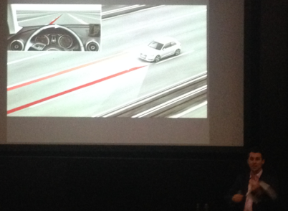

Dr Tim Marsh, Chairman of Ryder Marsh Sharman Safety looked at behavioural safety and the way we think when behind the wheel. There are differences between emotional and rational reactions, and some drivers are more prone than others to high-risk driving and road rage; it’s not just an age or boy racer issue.

It was mentioned several times that accidents can be caused by giving workers unrealistic deadlines which encouraged speeding, our [NWE] point which I raised was that we also put engineers in to a mode of thing about the next job instead of thinking about their driving to it.

Distractions are the major causational factor in incidents; it is bizarre that there is almost an acceptance that there will be deaths on the road and yet deaths in the workplace are not acceptable. When the Dr. listed issues that can precede an incident and can lead to a Section 172 Notice being served he included having a driving policy [not communicated and just held on-line]; having a command and control culture [even if not written as such]; an unreasonable workload; multi-jobs issued to driver; jobs issued via a PDA/laptop……………..this all started sounding familiar. These have all been cited in court as major contributory factors leading to RTC fatalities. Also mentioned were the actions of a company falling far short of what can be reasonable expected, having policies in place but not enforced. Also not acceptable to any court would be a manager who said he/she wanted something doing safely, but “*needs completion by Friday*”; whilst that may have been accepted by a court many years ago it absolutely will not be now – the culture and not the words is what the court looks at, what is considered and prosecuted.

Two issues raised by the excellent event;

1] When considering the grey fleet – it may be worth clarifying that that as the Branch pays expenses for journey(s) made does it also assume the responsibility of managing the journey(s) made on the Branches behalf, holding a Duty of Care to the Branch Office who is the driver? If so I could chase up a free App which is available shortly and could be adapted by the Branch to cover above issues raised if advice means that it does take on the responsible Duty of Care.

2] A useful contact whom I have already followed up was Frances Egerton from Cheshire Fire to confirm that we will be in touch and watch the forthcoming developments near Lymm; this is will be a full “street sized” fire and emergency training area first stage in March and fully operational in October 2017. Branch may use this in practice of emergency recovery form heights for example.



Derek Maylor

7761 098 9993

[safety@cwumswl.org](mailto:safety@cwumswl.org)

Driving Warrington 1016