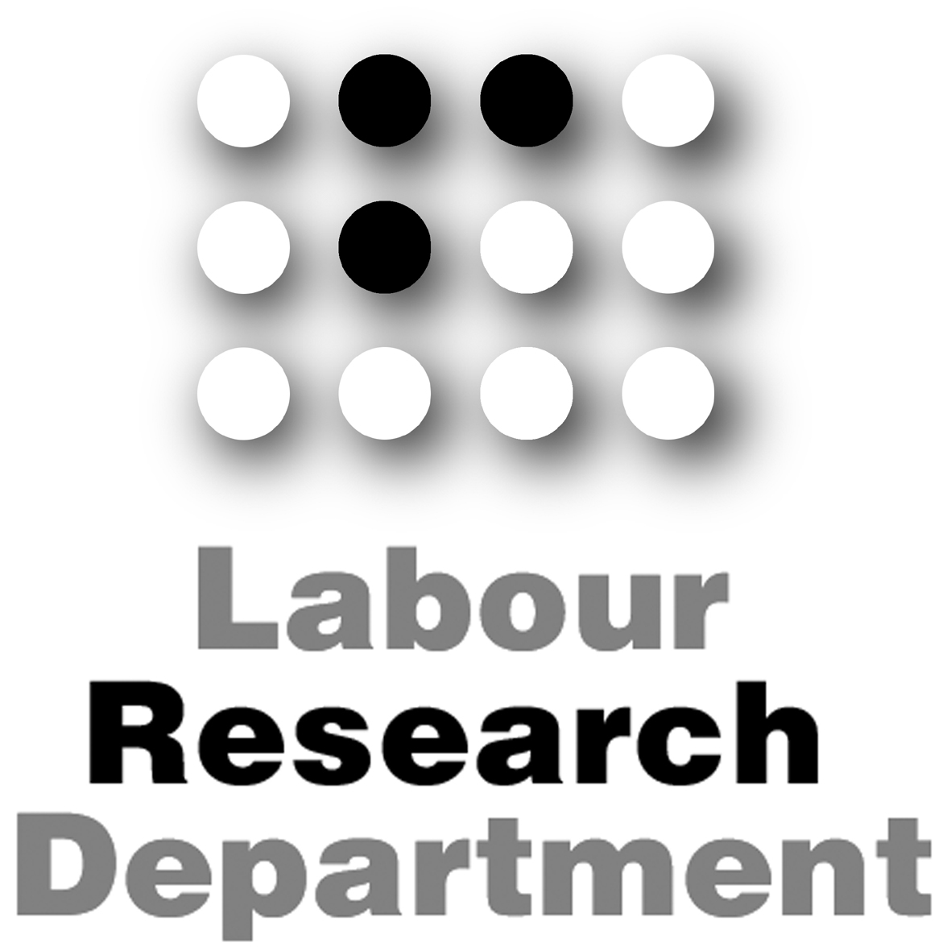
TEMPORARY WORKERS’
HEALTH & SAFETY

The Labour Research Department has been asked to research the health
and safety of temporary workers for the European Commission.

Temporary workers include:
- Workers with a fixed-term contract of employment
- Agency workers employed or supplied by an agency
- Casual and seasonal workers

Under European and UK law, temporary workers should have the same level of health and safety protection as other workers.

We want to find out whether that is in fact the case. We are looking for examples of good practice, where temporary workers do get protection. We also want to know where temporary workers are not being protected. Please answer as fully as possible and supply any additional documentation if necessary.
________________________________________
Yes No
1) Are there any temporary workers in your workplace?  
Roughly how many compared to permanent staff?

……………………………………………………………………………………………………………

2) Does your employer do the following for temporary workers? Yes No Not applicable
- Include them in risk assessments  
- Provide fire safety instruction  
- Ensure they get rest breaks  
- Ensure they don’t exceed working time limits  
- Supply free personal protective equipment (PPE)   
- Conduct a work station assessment if they use a computer   
- Ensure they get a free eye test if they use a computer regularly   
- Carry out health assessments if they do night work   
- Provide manual handling training   

……………………………………………………………………………………………………………

……………………………………………………………………………………………………………

3) Do temporary workers in your workplace get information From the employer 
about doing the job safely, before they start work? From an agency 

……………………………………………………………………………………………………………

4) Do temporary workers in your workplace get information From the employer 
on the qualifications and skills needed to do the job safely? From an agency 

……………………………………………………………………………………………………………
5) Do temporary workers receive training on the health From the employer 
and safety risks they face on the job? From an agency 

……………………………………………………………………………………………………………

……………………………………………………………………………………………………………

6) Does your employer carry out health surveillance (such as skin Yes No Not applicable
and urine tests, regular medicals) for temporary workers? to my work
- Noise   
- Hand-arm vibration   
- Chemicals, dusts or other hazardous substances   
- Asbestos   

……………………………………………………………………………………………………………

……………………………………………………………………………………………………………

7) Can you describe any examples of good or bad practice in your workplace concerning the health and safety of temporary workers?

……………………………………………………………………………………………………………

……………………………………………………………………………………………………………

……………………………………………………………………………………………………………

……………………………………………………………………………………………………………

……………………………………………………………………………………………………………

……………………………………………………………………………………………………………

Name:
Union/position:
Employer:
Address:

Telephone number:
E-mail:

Please tick if you would like to remain anonymous in the final report 

Please return to Paul Hampton, Labour Research Department, FREEPOST, 78 Blackfriars Rd, London, SE1 8YX (no stamp needed), phone 0207 902 9826 or e-mail paulh@lrd.org.uk

