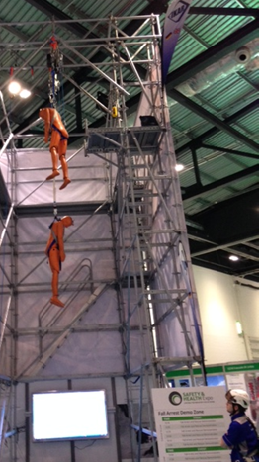Investigator 3; e-learning and software, there are many companies selling packages that look superb but they are not cheap. I 3 is an incident investigation and analysis tool that uses loads of words [they all do] so you can “plan, structure, and manage investigation process” or you could do the TUC Diploma at Alvescot. Root cause analysis software costs, as does emergency planning, incident investigations, risk assessment software and so on. One package looks like loads of yellow post stick notes – which could be replicated by using loads of post stick notes.
The Ladders Association sets standards for the industry and works with HSE etc. simply to promote safest possible ladder usage. Recognition ensures that members pursue safest standards – such campaigns as The Ladder Exchange, Ladder Lightweight, Advocate Scheme. Their strap line is “if its right to use a ladder use the right ladder”. I specifically wanted to speak to someone from the LA over what Openreach have said about forthcoming changes to working at height legislation and bottom end stability devices. A large part of the area was taken over by working at height including an impressive demonstration of rescue from hanging position at height.

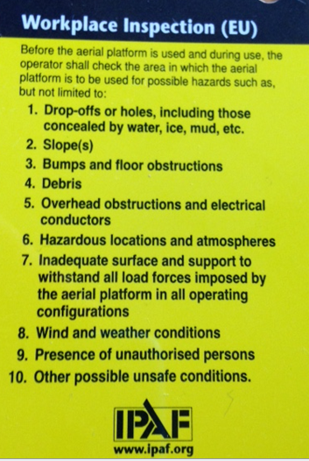The Lone Worker Theatre highlighted the excellent Suzy Lamplugh Trust, Suzy was the 25 year old estate agent who disappeared after she went to meet a client; she is presumed murdered and her body has not been found. Not sure if BT or RM have ever trailed anything to support our lone workers. A company called Skyguard have an excellent stand-alone system that ticks all the boxes I can think of, especially the Man Down Alarm particularly for BT engineers. A mobile app ok but these can affected by poor mobile coverage whereas a unit like Skyguard searches for best reception not one supplier.
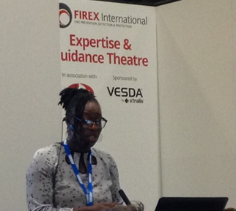Kizzy Augustin talked about the key fire risks such as FRAs being incomplete, not suitable and the come backs for delegated responsible person. The Regulatory Reform (Fire Safety) Order 2005 Article 32 (1) & (8) refers to senior managers and Fire and Rescue Authorities are increasingly looking to prosecute, maybe even considering it as an income stream whereby they get costs awarded. Managers can no longer just say they were not aware, they should be aware and can be prosecuted for consent or connivance or neglect. Article 23 refers to employees and can be seen as aggravating feature in court if a manager directs cuts which can be considered as putting cost before safety. In March Section 85 of the Legal Aid, Sentencing and Punishment of Offenders Act removed limits on magistrate court fines.
The keynote preacher on the Wednesday was described by The Guinness Book of World Records as 'the world's greatest living explorer'. He is one of the UK's leading motivational speakers and is in huge demand domestically and internationally. He has completed 22 expeditions and raised over £16m for the Marie Curie cancer charity. Unfortunately he was too interesting to take any notes!!! However I do remember him saying he is always trying to beat the Norwegians; that when looking for anyone to join him on an expedition he needs to know their motivation and not their qualifications; if you are born stupid – you’re probably going to stay stupid. He once did an army course on escaping from dogs at night [which I think was made up for effect]. Well worth listening to if ever an opportunity.
Legislation update services – lots of companies selling the obvious, if we need to know what’s coming up on safety legislation we can have a look at the HSE website for a start [and Environment Agency etc.], or spend £500 a year on a company who will do that then tell you what is on it; sure they make it look nice though.
Maybe the Coord could design our own bite sized single issue “how to” guides, put them onto YouTube via links from the website? “Think big – start small”.
Derek Maylor - 19th.June 2015.
Safety Expo 0615

