The Posturite Showcase
St Martins-in-the-Fields
London
26th.February 2015, 12:00 -19.00.

A day led by ergonomic experts about our products and services with demonstrations and exclusive previews of new products such as a sit/stand bench desking system.

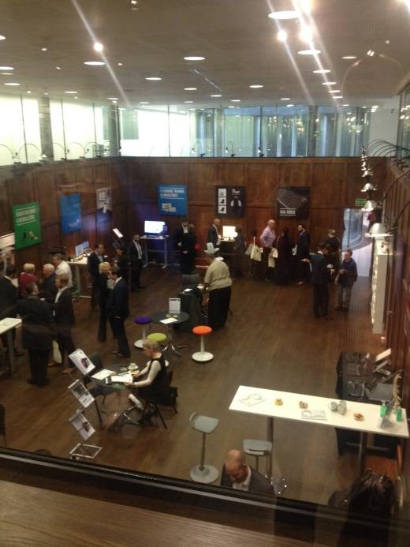

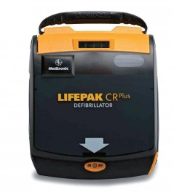Automated External Defibrillator (AED or a defibrillator) – thirty thousand cases per year of sudden cardiac arrest (SCA) outside hospital and the survival rate is poor – around 7%. Every minute following an arrest there is a 12% drop in survival and it affects any age group, it is not an old person’s issue. Defibrillators save lives, Brighton Football Club had three SCA’s last year and all three survived following prompt action by staff with defibrillators. The charge is delivered by a renewable charge stick, the defibrillator is kept serviceable by a built in battery. The defibrillators need maintenance such as renewing the charge stick every two years and after a use in real life, pads will also then need renewing. There is [on many defibrillators] a digital screen that will tell you when to renew the stick; therefore any defibrillators should be on a maintenance regular schedule such as the same time as a fire alarm check. If you are going to have a SCA, have one at an airport, all staff are trained and there will be sufficient defibrillators distributed around the site.

Employment Law – the legal duty to make reasonable adjustments under the Equality Act 2010, this includes mental impairment. If the medical advice is that an employee who is ill with stress will continue to be so impaired for twelve months then it is under the Act. There is a case ongoing over obesity and body mass index (BMI). The legal duty to make adjustments includes the discrimination having to be substantial and the employer must know or ought reasonably to know. See ECHO Code for further advice.

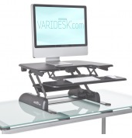Enablement - cost effective reasonable adjustments and the provision of ergonomically supportive equipment can be sought after a Risk Assessment (RA). Specialty seating, desking, workstation accessories are readily available to prevent musculoskeletal disorders. Newer support includes assistive technology such as on-line dyslexia screening and colour overlay assessment.

Stand up desking – relatively new idea of highly adjustable bench desking allowing work from a standing position. This can also be supported by a standing board such as Gymba Board which is encourages slight movement by balance and lessening strain to the back. Not designed for all day use but as an addition to the work stance; if standing all day without varying posture risk developing health problems such as varicose veins, joint damage, and circulatory problems.

Use of portable communication equipment – use the right tool for the right job and simple things like tilting the tablet, hold the mobile screen higher, keep screens ultra clean and look away from screen regularly. Do not use for lengthy periods and consider using an external keyboard. For the best tip, try ringing and speaking to the person instead.
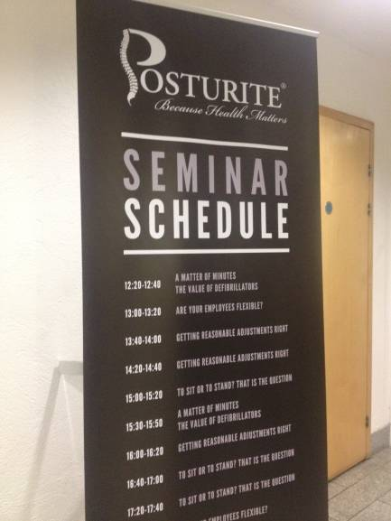
Other issues covered were effective back care, DSE helpful hints, the art of sitting, car ergonomics, workstation exercises and laptop hints; literature available if required.

Derek Maylor,
26th.February 2015.

http://www.posturite.co.uk/
Posturite 0215

