Health & Safety North Bolton Arena Wednesday 12/10/16.

Emma Evans, Pinsent Masons.

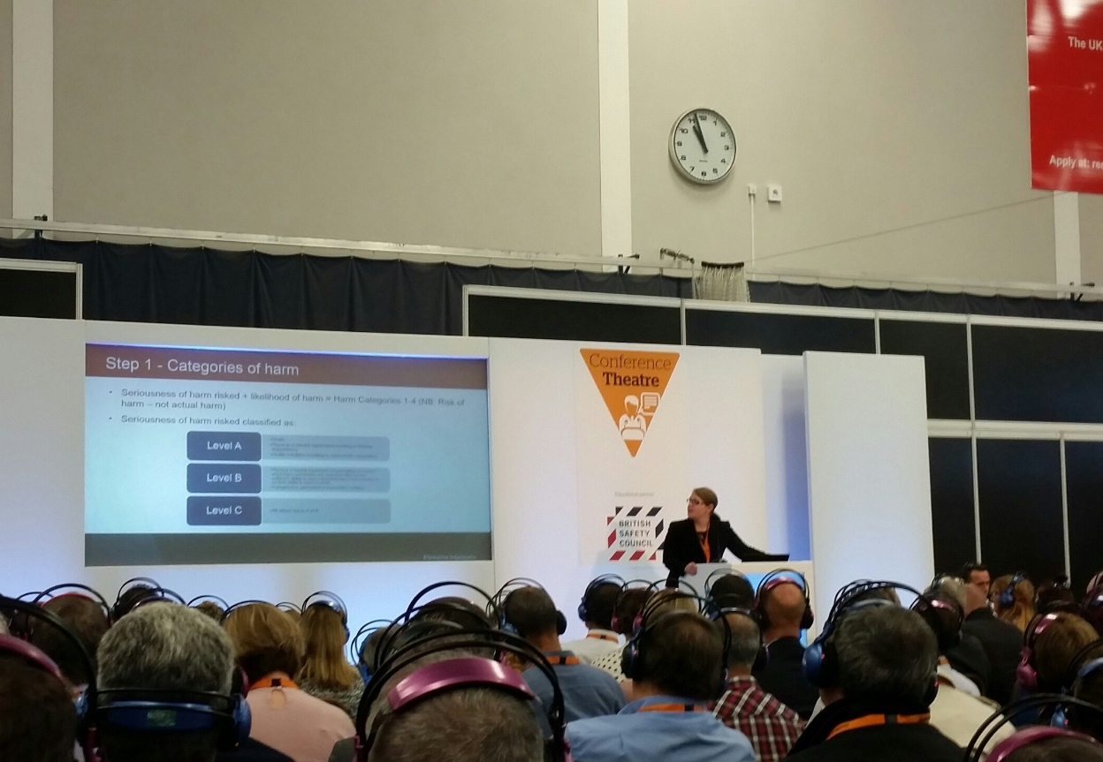

Emma Evans, Legal Update

Implementation of the Sentencing Council Guidelines for health and safety offences have seen a significant increase in the cost of fines, drawing renewed attention to the importance of compliance.

Section seven refers to employees & to prosecute under section 7 you must be able to prove that a person is:

- employed, and
- 'at work' in the course of his/her employment, and either
- did not take reasonable care for someone's health and safety (including their own), or
- did not co-operate with their employer so far as was necessary to enable their employer to comply with a statutory duty or requirement.

What is 'reasonable care' and 'necessary to enable' needs to be considered in the context of the employer's provisions. For example, a machine operator who has received inadequate training might be considered to have acted reasonably in all the circumstances if he/she removes a guard from a machine and continues to use it, and this is the generally accepted and condoned practice in the company. In other circumstances the same act might be considered unreasonable, if the employee has received proper training, if the guard in question is sufficient, and if removal of guards is neither accepted nor condoned in the company. 'So far as is necessary' does not require employees to compensate for employers' failure to make adequate provisions. This remains the responsibility of the employer.

Since 12th March 2015 Magistrates courts are to take more H & S cases. From the 1st Feb 2016 (inc Food safety & hygiene) there is a nine step approach to this. Part of which includes;

- Culpability/harm; not actual harm
- Fail to have plans (e.g. an evacuation plan)
- Category of harm ABC
- Category of organisation Micro/small/medium, this will affect the size of the fine given.

The old fatality fine max was £100,000 new staring point is now £160,000! Section seven covers individual H & S responsibility. The Corporate manslaughter bill has been in force for over eight years now. There have been 27 to date, that is 21 convictions, 5 acquittals & one is still ongoing.

Here are some examples;

Warwick Castle. £350,000 fine

http://www.telegraph.co.uk/news/uknews/law-and-order/9226155/Warwick-Castle-fined-350000-as-after-grandfather-plunges-to-death-in-moat.html

Baldwin crane hire. £700,000 fine

https://www.healthandsafetyatwork.com/corporate-killing/baldwins-crane-hire-easton

Travis Perkins, in Milton Keynes received a 2m fine when a customer who was loading planks onto his car fell backwards onto the floor & was then ran over by a company truck, that was reversing, suffering severe crush injuries.

http://www.miltonkeynes.co.uk/news/travis-perkins-fined-2m-after-death-of-customer-in-milton-keynes-1-7356170

It is important to note that companies were severely dealt with who failed to take advice of external or their own internal safety professionals!

Health & Safety North Bolton Arena Thursday 13/10/16.

Not quite as busy as yesterday, but it was good to see a couple of groups of young people taking an interest in H & S! Looking at the exhibitors & also asking them questions!

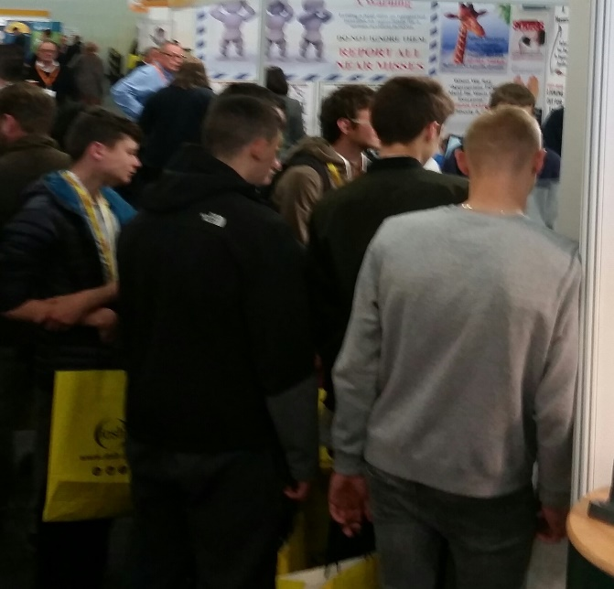
Are these young men the next generation of health & safety professionals?

Chris Morrison from Clyde & Co.

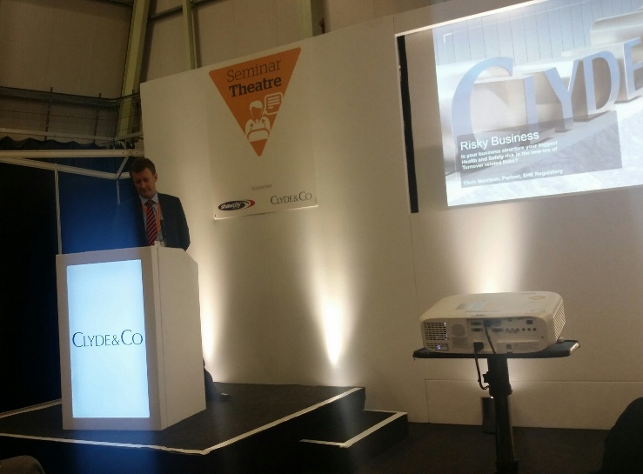

Mr Morrison is widely acclaimed as one of the UK's leading Health and Safety lawyers, recognised in the 2016 legal directories as a Band 1 ranked lawyer in Chambers & Partners (UK Wide Health and Safety) and as a 'Leading Individual' (London & UK) within Legal 500.

He is highly experienced in guiding Global and major UK businesses through incident related investigations and prosecutions, his expertise spans Health & Safety, Corporate Manslaughter, Corporate Homicide (Scotland), Environmental Crime, Fire Safety, Food Safety and Coroners Inquests.

Mr Morrison heads the 24/7 incident response team, he seeks to prevent matters becoming either a crisis or a drama by providing strategic, responsive and no-nonsense advice to protect client's immediate and long-term reputation and revenue. Having commenced his legal career in the 1990's as an orthodox crime lawyer, he has been specialising since 2001 in Regulatory Crime and continues to undertake interviews under caution, trial preparation, Coroner’s inquest and advocacy. He is an accomplished trainer in the Health & Safety field working for external training providers as well as own clients.

All about money!

It’s all about money with some large companies, would they look at splitting them up to protect profits? Don’t forget that with H & S it’s the reverse burden of proof & with a fatality it takes on average between three to five years to resolve in court.

ABC Plc.

ABC Holdco Ltd

High risk area of business
Low risk area of business

To help protect revenue some company’s may wish to split their company, although this can have implications on tax, employee’s terms & conditions etc.

If there is fatality within a company investigators will be brought in & they have many powers & functions. The role of the Police is to identify weather the death has resulted from a serious criminal offence (other than a H & S offence). In practice this means they will primarily consider whether the business has committed an offence of Corporate Manslaughter and/or any individual(s) may be liable for Gross Negligence Manslaughter.
They gather evidence by securing the scene & collecting physical evidence, e.g. photographs, measurements, samples etc. They will also take copies of books, records & documents, they will obtain witness statements, test equipment & interview any suspects under caution!

What to do in the unfortunate event of a fatality within your company.
Do not panic, there are people who will give you help & advice, appoint a single point of contact (SPOC) within the business who will liaise with the investigators. All employees must be advised on who is investigating & be given the details of the SPOC so that any requests for information or witnesses can be routed through them.
Do not obstruct the investigators, this in itself is a criminal offence. Do co-operate with the investigation, albeit do so cautiously, taking legal & expert advice throughout. Do NOT volunteer information/documents to the investigator’s, even if you believe that it will assist the business. Remember nothing that is said is “off the record”.
Notify your lawyer of any information/document requests made by the investigators; they will then advise you of what specific disclosure should be provided. It is important to retain a duplicate bundle of documents provided to the investigators.
Always keep a record of the investigation (who has been interviewed, what documents have been requested, who was on site, what investigations have been carried out etc.) It is important that you do not start an internal investigation until you have taken legal advice. They will instruct the investigation so as to enable legal privilege (i.e. confidentiality) to be claimed over the resulting report. This means it does not have to be disclosed.
It is also advisable to seek legal advice as to the available options for employees to asked to provide witness evidence before any statements are given. In some cases, it is beneficial to seek independent legal representation for individual employees.
Do NOT release a press statement unless you have agreed the content with your chosen regulatory lawyer! Do consider whether the incident is RIDDOR reportable. Lastly always seek advice upon receipt of a Prohibition notice, an Improvement Notice or a Notice of Contravention. All are capable of challenge but have a short timeframe within which any appeal must be launched.
H & S North 2017.
Next year the event is to move from Bolton to Manchester! The new venue will be EventCity, Manchester on the 10-11th October 2017.

John Southwell 2016.

