Tyred Maths Investigation

LO – I can collect information, construct a bar chart and analyse my data.

1.
I am going to find out the following things
- _____________________________
- _____________________________
- _____________________________

My key question is ______________________________________________________________________________.

My results will show ____________________________________________________________________________________________________________________________________________________________.
2. My data

Car Reg | Date of its oldest tyre

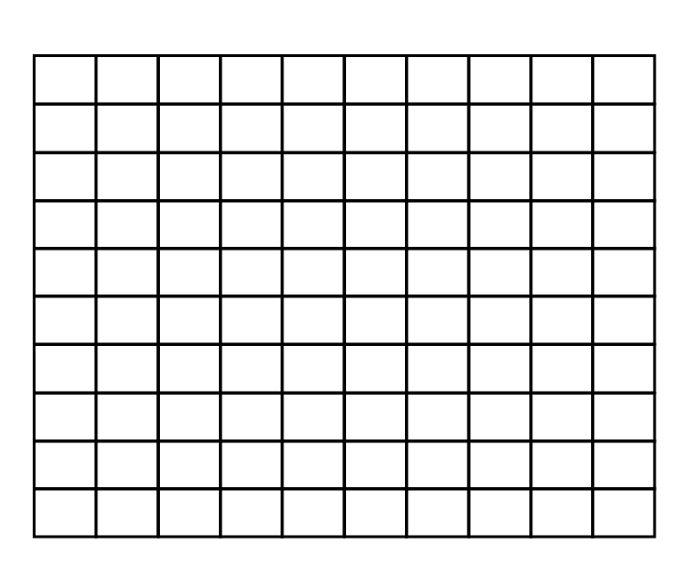
3. My results

4. My findings

I have found out __________________________________________________________________________________________________________________________________
____________________________________________________

